

**YASS HIGH SCHOOL**

HUMAN SOCIETY AND ITS ENVIRONMENT

*We do not inherit the earth from our ancestors,*

*we borrow it from our children (native American proverb)*

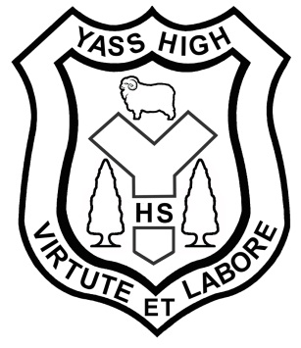

**Year 7 & 8 History Course Outline 2012**

**Overview**

Welcome to Year 7 and 8 History! This year we will study what history is all about, and look at several societies and civilisations from the past. You will develop skills in historical inquiry, including the examination of sources and artefacts, and learn to use these to better understand elements of our past. Our focus will largely be on ancient and pre modern societies, the features of each and the impact they have had on the world as we know it today.

**Course Content**

The course consists of FOUR (4) units of work, some of which with sub topics. The topics include:

1. Unit One: Investigating History
   * What is History?
   * Tools and Evidence
   * Heritage
2. Unit Two: Societies and Civilisations of the Past
   * Ancient Rome or Ancient Egypt
   * Medieval Europe
3. Unit Three: Contact and Colonisation

* Australia
* North America
* South and Central America

1. Unit Four: The Making of the Modern World

**Equipment**

The following equipment is expected to complete this course:

* A4 Exercise book (at least 128 pg)
* Colour and HB pencils and pens
* PVC Pocket Folder
* Scissors, ruler, protractor, and glue stick
* USB Stick

**Assessment**

There will be FOUR (4) items of assessment each semester:

|  |  |  |  |
| --- | --- | --- | --- |
| **Task** | **Description** | **Weighting** | **Date** |
| 1 | Investigating History Test | 20% | Week 8 Term 1 |
| 2 | Semester Assignment | 40% | Week 2 Term 2 |
| 3 | Semester Examination | 30% | Week 5 Term 2 |
| 4 | Book Work | 10% | Periodic |

Other homework, assignments and quizzes will build knowledge and skills, and test your understanding. These tasks are important practice or background activities for class work and discussions, and provide an indication of your progress in history. They MUST be completed to a satisfactory standard as a part of the Board of Studies’ requirement for students to apply themselves with diligence to ALL tasks.

Extensions will only be given with advance notice, serious misadventure or with a medical certificate. Computer malfunction will not be grounds for extensions on the due date. Students will be penalised 25% per day the assignment is late and may be required to complete major tasks during lunch times.

**Topic Sequencing**

|  |  |  |  |  |  |  |  |  |  |  |
| --- | --- | --- | --- | --- | --- | --- | --- | --- | --- | --- |
| **Week** | **1** | **2** | **3** | **4** | **5** | **6** | **7** | **8** | **9** | **10** |
| **Term 1**  **2012** | Investigating History |  |  |  |  |  |  | Ancient Rome/Egypt |  |  |
| **Term 2**  **2012** | Ancient Rome/Egypt |  |  |  | Medieval Europe |  |  |  |  |  |
| **Term 3**  **2012** | Australian Colonisation |  |  |  |  | North American Colonisation |  |  |  |  |
| **Term 4**  **2012** | South/Central American Colonisation |  |  |  |  |  | Making the Modern World |  |  | ## |